COS30031 Games Programming

Learning Summary Report

<STUDENT NAME> (<STUDENT ID>)

Self-Assessment Details

Update header with your name and id. Then delete this box.

The following checklists provide an overview of my self-assessment for this unit.

|  |  |  |  |  |  |
| --- | --- | --- | --- | --- | --- |
|  | Pass (P) | Credit (C) | Distinction (D) | High Distinction (Low HD) | (High HD) | |
| Self-Assessment (please tick) | ✔ |  |  |  |  |

*Self-assessment Statement*

Tick the box with the grade you are applying for.   
Then delete this box.

|  |  |
| --- | --- |
|  | Included? (tick) |
| Learning Summary Report |  |
| Time-boxed Demonstration Activity (Lab Test) in Doubtfire | Check that you have included the minimum required details. Tick these boxes (and ones for higher grades as applies). Then delete this box. |
| Complete Pass (“core”) task work, approved in Doubtfire |  |

*Minimum Pass Checklist*

|  |  |
| --- | --- |
|  | Included? (tick) |
| Additional non-core task work (or equivalent) in a private repository and accessible to staff account. |  |
| Spike Extension Report (for spike extensions) in Doubtfire |  |
| Custom Project plan (for D and/or low HD), and/or High HD Research Plan document in Doubtfire (optional) |  |

*Credit Checklist, in addition to Pass Checklist*

|  |  |
| --- | --- |
|  | Included? (tick) |
| Custom Project Distinction Plan document, approved in Doubtfire |  |
| All associated work (code, data etc.) available to staff (private repository), for non-trivial custom program(s) of own design |  |
| Custom Project “D” level documents in Doubtfire, to document the program(s) (structure chart etc) including links to repository areas |  |

*Distinction Checklist, in addition to Credit Checklist*

|  |  |
| --- | --- |
|  | Included? (tick) |
| Custom Project “HD” level documents in Doubtfire, to document the program(s) (structure chart etc) including links to repository areas |  |

*Low High Distinction Checklist, in addition to Distinction Checklist*

|  |  |
| --- | --- |
|  | Included? (tick) |
| High Distinction Plan document, approved in Doubtfire |  |
| High Distinction Report document, in Doubtfire, which includes links to repository assets |  |
| All associated work (code, data etc.) available to staff (private repository) for your research work |  |

*High High Distinction (Research) Checklist, in addition to D/Low HD Checklist*

# Introduction

This report summarises what I learnt in COS30031 Games Programming. It includes a self-assessment against the criteria described in the unit outline, a justification of the pieces included, details of the coverage of the unit’s intended learning outcomes, and a reflection on my learning.

# Overview of Pieces Included

This section outlines the pieces that I have included in my portfolio…

*Describe the pieces you have included in your portfolio.*

*This should contain a* ***list*** *of all the pieces, along with a short statement of* ***why*** *each piece was included.*

# Coverage of the Intended Learning Outcomes

This section outlines how the pieces I have included demonstrate the depth of my understanding in relation to each of the unit’s intended learning outcomes.

## ILO 1: Design

*Discuss game engine components including architectures of components, selection of components for a particular game specification, the role and purpose of specific game engine components, and the relationship of components with underlying technologies.*

*Describe what you have included in your portfolio that demonstrates your ability in relation to this outcome.*

* *Pass: Identify where in your lab test or core spike work the topics that need to be discussed have been covered.*
* *Credit: Descriptions must contain depth and relate the concepts to each other, and demonstrate their practical application.*
* *Distinction, High Distinction: relate to your project and/or research*

## ILO 2: Implementation

*Create games that utilise and demonstrate game engine component functionality, including the implementation of components that encapsulate specific low-level APIs.*

*Describe what you have included in your portfolio that demonstrates your ability in relation to this outcome.*

* *Pass: Working implementations / demonstrations from the spike work.*
* *Credit: Additional work that extends the core spike work features*
* *Distinction, High Distinction: relate to your project and/or research*

## ILO 3: Performance

*Explain and illustrate the role of data structures and patterns in game programming, and rationalise the selection of these for the development of a specified game scenario.*

*Describe what you have included in your portfolio that demonstrates your ability in relation to this outcome.*

* *Pass: Identify where in your lab tests and/or core spike work where you have explained and illustrated this ILO.*
* *Credit: Evidence of depth in the portfolio work and explanations provided.*
* *Distinction, High Distinction: relate to your project and/or research*

## ILO 4: Maintenance

*Explain and illustrate the role of data structures and patterns in game programming, and rationalise the selection of these for the development of a specified game scenario.*

*Describe what you have included in your portfolio that demonstrates your ability in relation to this outcome.*

* *Pass Identify where in your lab tests and/or core spike work where you have explained and illustrated this ILO.*
* *Credit: Evidence of depth in the portfolio work and explanations provided.*
* *Distinction, High Distinction: relate to your project and/or research*

# Reflection

## The most important things I leant:

*Think about topics covered, but also other general things you may have learnt. Think about what you have learnt in this subject, and reflect on what you think were key learning points, or incidents. Did you learn what you wanted/expected to learn?*

## The things that helped me most were:

*List and explain*

## I found the following topics particularly challenging:

*List and explain – if none explain why*

## I found the following topics particularly interesting:

*List and explain – remove if none*

## I feel I learnt these topics, concepts, and/or tools really well:

*List and explain – if none explain why, refer to your pieces for evidence to support your claims*

## I still need to work on the following areas:

*List and explain – if none explain why, refer to your pieces*

## My progress in this unit was …:

*Include a screenshot of your progress graph from DoubtFire, and comment on what happened from your perspective… what does the graph say about how you approached the unit? (Login to Doubtfire to get your graph* [*https://doubtfire.ict.swin.edu.au*](https://doubtfire.ict.swin.edu.au)*)*

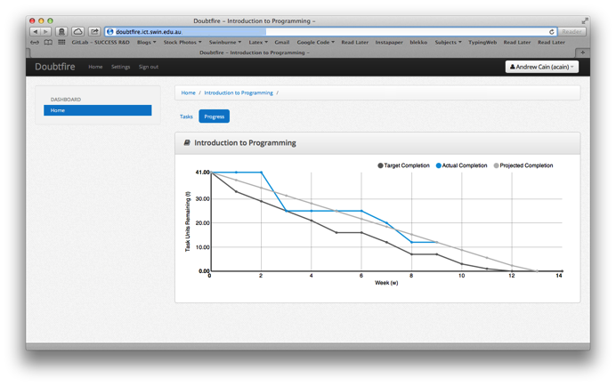

## This unit will help me in the future:

*How will the things you learnt relate to the rest of your studies, and career. What have you learnt that will be valuable for you in the future?*

## If I did this unit again I would do the following things differently:

*List and explain, how will you approach learning in the future? What things worked well, but what could you change to make sure you did better next time?*

## Other…:

*Add any other reflections you think help you demonstrate your learning*

# Conclusion

In summary, I believe that I have clearly demonstrate that my portfolio is sufficient to be awarded a …. grade.

*Add more points if you wish, but don’t add anything you haven’t already mentioned in an earlier section*